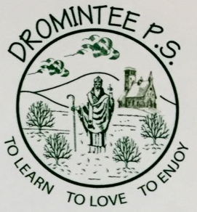 | Dromintee Primary School
 | 8 Ballynamadda Road,  Killeavy,  Newry, Co Down,  BT35 8TD | Telephone: (028) 3088 8383  Fax: (028) 3088 8470  www.drominteeps.com  Email: info@dromintee.killeavy.ni.sch.uk
21st September 2018
Dear Parents,
Everyone has settled well into the 2018-2019 academic year. I am delighted to see everyone smiling and happy. I’d like to share our plans for charity and fundraising for the year ahead with you. As you can appreciate we get a lot of requests for sponsorship and we have to choose what best suits the school.
There are likely many positive aspects to the promotion of charities in schools. Charitable activities are important to develop a sense of citizenship – in terms of individual engagement, participation in collective school activities, and engendering a broader sense of social responsibility.
Many schools in our area have agreed to help fundraise for Ellen in term 1. We have information on our website. We are adopting her as a school on Wednesday 26th September. We will have a non-uniform day and the children are asked to donate from their pocket-money. All monies received on this day will be passed to Ellen’s family.
In line with previous years, term 1 sees the school’s only fundraiser – a fancy dress sponsored walk on Friday 26th October. We depend on these funds to keep us ‘afloat’ in consumables though out the year.
At end of term 1 we have been making ‘shoebox’ presents for Newry Helping the Homeless. We propose doing that again this year as they were so well received and appreciated last year.
Last year in Term 2 we raised £800 for Trócaire. We hope to focus on Trócaire during Lent again this year.
In term 3 we plan to have a dedicated day for Action M.S. The children will be taken to Kilbroney Park on 1st May to do a walk for M.S.
Thank you for supporting our efforts to raise awareness and raise funds.
Mrs W McKeown
Term 1 Non-uniform day Wednesday 26th September Ellen’s Journey
Fancy dress Friday 26th October School funds
Shoebox gift December 3rd – 6th NHTH (homeless)
Term 2 Trócaire box Lent Trócaire
Term 3 Walk for MS Wednesday 1st May Action M.S.

