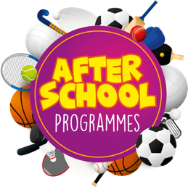
Dromintee
Primary school

1st Term – 2nd Block

Gaelic Soccer Hip Hop
Mon 6th November
Mon 13th November
Mon 20th November
Mon 27th November
Mon 4th December
Mon 11th December

Mon
Thur 9th November
Thur 16th November
Thur 23rd November
Thur 30th November
Thur 7th December
Thur 14th December
Fri 10th November
Fri 17th November
Fri 24th November
Fri 1st December
Fri 8th December
Fri 15th December

Primary 1 – Primary 3 (2.00pm-3.00pm each week) Primary 4 – Primary 7 (3.00pm-4.00pm each week)

To secure a place for your child you must enrol online via www.burnsskillsschool.co.uk This is very easy and straightforward. Click ‘secure your place’ at the top of the website. Then scroll down to find your child’s school and the correct activity to enrol. Cost: £30.00.

Deadline for payment is Sunday 5th October. This is a great opportunity for your child and certainly one not to be missed. When in attendance we would advise that all children wear appropriate clothing with a pair of trainers suitable for indoor and outdoor.

Payment options: Online

Thanks
Aaron & Andrew
Burns Skills School

