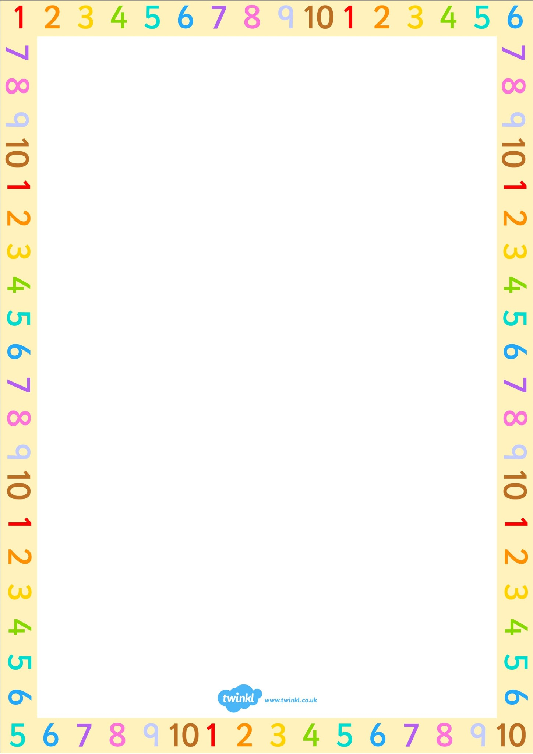

Maths Week+ Book Week in Dromintee

Monday 16th October – Friday 20th October

Dear Parent,

To celebrate our learning and achievements in Numeracy we will be participating in Maths Week. A number of events and activities have been organised throughout the week to encourage our children to engage in a fun way with the subject and to build on their skills and understanding. Your support would be very much appreciated and we encourage you and your child to set aside time to access Mathletics tasks set by your child’s class teacher and perhaps check out [www.mathsweek.ie](http://www.mathsweek.ie) website where you can find out more information on Maths Week 2023.

Whole school events include:

* Maths Early bird morning (Numberblocks in the hall before 9am)
* Run the weekly Maths mile as a class (time)
* Opportunity to use Izak 9 in class
* Access Mathseeds/ Mathletics at home (P1-7)
* Guest visitors to each class discussing the importance of Maths in their jobs
* STEM workshops on Wednesday 18th October led by Sentinus

*A huge thank you to all the parents who have helped us with Maths Week, in particular those who are sharing their personal Maths experiences with different classes. We greatly appreciate your time and support with this initiative.*

We hope that you will embrace Maths Week in your home and look forward to a very fun, active week celebrating our learning in this key area of the curriculum. Photos of events and visitors will be posted on our school website.

In conjunction with this we are also celebrating Book Week NI. As a little challenge we are asking the pupils to come up with the title of a book that has a link to Maths, eg. The Greedy Triangle by M. Burns, Where’s Spot? By Eric Hill, Spinderella by J. Donaldson.

If your child finds a book they can bring it into school or tell their teacher the name of it. Anyone who participates in this challenge will be entered into a Coded Number Book Competition by choosing a three digit number to try to crack the code to win a prize.

Yours sincerely,

Mrs N. Mc Ardle Mrs A. Mc Naughton

Numeracy + Literacy co-ordinators