Dromintee Primary School swap & save uniforms
Pre-loved uniforms wanted!

Please come and take what you need, you can donate uniforms your children have outgrown.
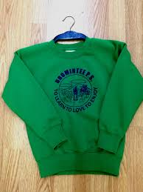

Swap, don’t shop!
Save money and be more eco-friendly with school uniforms.

When: Wednesday 24th August 10am-12pm
Where: Dromintee Primary School

