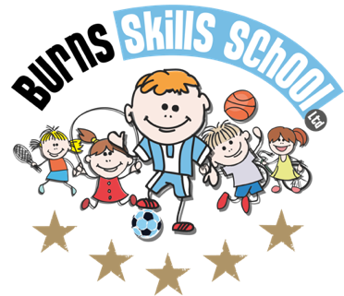
Tag Rugby

Dear Parent/Guardian
We are delighted to announce that Burns Skills School are running one of their fantastic afterschool programmes within the school grounds this year. The programme will consist of 10 weeks which will entail age appropriate educational sessions that will have a main focus of fun whilst improving each child’s technical ability.
Dates of programme:
Monday 17th Jan
Monday 24th Jan
Monday 31st Jan
Monday 7th Feb
Monday 21st Mar
Monday 28th Mar
Monday 7th Mar
Monday 14th Mar
Monday 21st Mar
Monday 28th Mar

Primary 1, 2, & 3 (2.00pm-3.00pm each week) Primary 4, 5, 6 & 7 (3.00pm-4.00pm each week). To secure a place for your child you must make payment of £40.00 at our registration morning.

Registration date & time: Tuesday 11th of January at 8.15am

Note: You do not need to print any tickets off our website.

Benefits of programme:

- Improves technical ability
- Enhances physical, mental and social attributes (confidence building)
- Professional coaching
- Controlled and structured physical activity
- Teaches respect for one and all
- Make new friends

Deadline for forms & payment is Tuesday 11th January. This is a great opportunity for your child and certainly one not to be missed. When in attendance we would advise that all children wear appropriate clothing with a pair of trainers suitable for indoor and outdoor.

Payment options: Cash Only

Thanks
Aaron & Andrew
Burns Skills School

