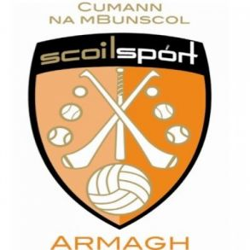

15th June 2021
Dear Parents/ Guardians,

Cumann na mBunscol will mark 50 years in existence this year.
This week in school we have been engaging in lots of GAA themed activities to celebrate this fantastic institution.
Our children have been taking part in daily activities and skill challenges set by a range of high profile athletes across the counties, creating wonderful art work, writing stories and poems and acting out our favourite memories from GAA experiences. Some of our classes have listened to messages from prominent current and past players and have had inspiring conversations about how we value the GAA as a community.
As part of our whole school celebration of 50 years of Cumann na mBunscol we are inviting our pupils to come to school on Thursday 17th June wearing either their club or county colours.
We look forward to everyone getting involved and enjoying the festivities.
Regards,

Mrs. McKeown

