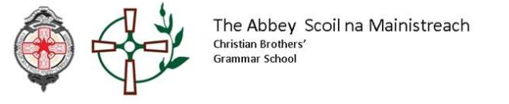

Dear Principal

As we hopefully are entering the final stages of lockdown, I am sure you are looking forward to having pupils back in school and will welcome the usual challenges that brings.
No doubt you are at the stage of advising Primary 7 parents on future schools and options for their son. We have published our Admissions Criteria on our school website at https://www.abbeycbs.org/admissions/ and obviously it is also available through the EA website which may be linked through the school website. The school prospectus and introductory film is also available through the school website.
We have had several requests asking how many boys are usually admitted under each criteria and how that impacts on a pupil’s chance of acquiring a place this year. This is particularly concerning for those boys who are the eldest child applying to the school.
- The initial criteria of son of staff member may be largely discounted as it accounts for so few annually.
- Family relationships through brothers currently or having attended and paternal relationships usually accounts for just over a third of the student intake.
- Eldest eligible child, i.e. eldest boy or first boy applying to the school will account for 60% on average.
- The use of FSM usually is used to distinguish as a subsidiary criterion if particular categories take numbers above the admissions number.
I hope this information is useful when advising parents to alleviate their fears, particularly if they feel they have no previous family relationship with The Abbey. Ultimately, my advice is to apply by first preference if they feel their son will thrive in the particular setting at The Abbey and the obvious academic and competitive challenges they will face there.
Please ask any parent to contact the school directly if they have particular concerns.
Many thanks for your cooperation during difficult times and please feel free to contact me at any time.

Kind Regards
Seán Sloan
Principal

