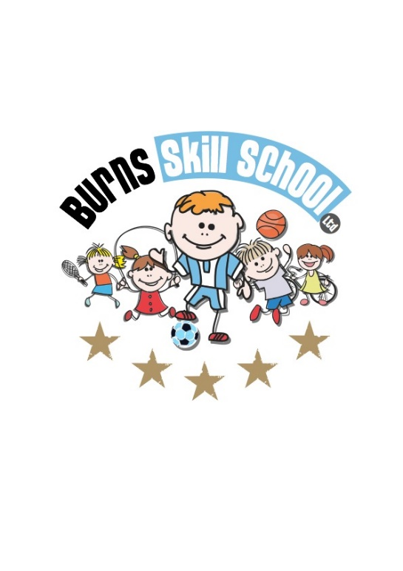
Burns Skills School
Parent/Guardian Consent Form

Name of Child …………………………………………………………………..
Age …... D.O.B ………... Child’s School ………………….........................
Parent/Guardian Name ………………………………………………………..
Address…………………………………………………………………………..
…………………………………….............
Tel (day): ……………………. Tel (evening): ……………………..
Mobile: ………………………. E-mail: ……………………………..
(Please make sure you are available at any of these numbers during the hours of coaching)
Alternative Contact Name: …………………………………………
Alternative Contact Number: ……………………………………….

Medical Details
Doctors Name………………………………….. Tel: …………………………
Address ………………………………………………………………………….
Is your child currently on any medication? Yes No
Medication or Conditions ……………………………………………………...
……………………………………………………………………………………
…………………………...……………………………………………………….
(If your child suffers from any conditions or takes any medication can you pleases state above, if child requires inhaler all inhalers must be brought to coaching sessions)
I give permission for my child to take part in Burns Skills School coaching and to be included in promotional photographs for example local newspapers, Twitter and Facebook etc.
Signed Parent/Guardian: …………………………….. Date: ………………
Twitter - @Burns_skills Facebook – Burns Skills School Email – coaching@burnsskillsschool.com
Website – Burns Skills School Snapchat – Burns_skills

