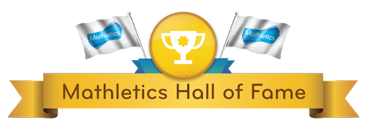

Amarah Kenny
Daithi Hughes
Eibhleann Hughes
Jack Mathews
Amarah Kenny
Ryan Toale
Oran Toale
Emma Toale
Ferghal Mc Coy
Amy O’Neill
Aurimas Jankus
Aine Power
(yes 11 in this week’s list as you will see joint points for two pupils on the generated Mathletics report)

