My Townland of Dromintee

About Dromintee Parish
Dromintee/Drumintee is a small village and townland in County Armagh, Northern Ireland. It lies within the Newry and Mourne District Council area. It sits within the Ring of Gullion. Dromintee is in the civil parish of Killeavy.

My Townland Dromintee / Droim an Ti
Facts about my townland of Dromintee
- 428.84 hectares.
- 1.66 square miles
- 1059.68 acres
Within Co. Armagh it is the 21st largest townland.
Nationwide it is the 2302nd largest townland that we know about.

Michael J Murphy the famous folklorist was from my townland of Dromintee. He was born in Liverpool in 1913. His parents were natives of Dromintee and in 1922 when he was eight and a half years old, they returned to Dromintee. He attended Dromintee national school. After the publication of his first book ‘At Slieve Gullion’s Foot’ in December 1941, he joined The Folklore Commission and went on to record what is probably the largest collection of oral tradition ever collected in the English speaking word. He died in 1996 and is buried in Darver cemetery with his wife Alice.

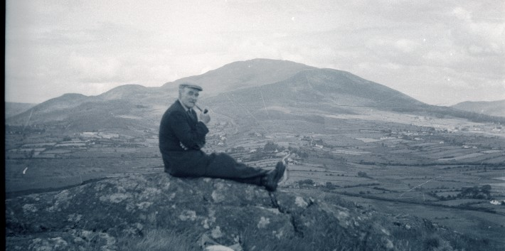

Fr. Martin O’Hare from the mountain road is the only parishioner to be ordained in Dromintee church. He is now a parish priest in West Cork.

The Borders of Dromintee townland

This is a picture of the border between Dromintee townland and Aghadavoyle townland and on the right is a picture of the border between Dromintee and Annahaia.

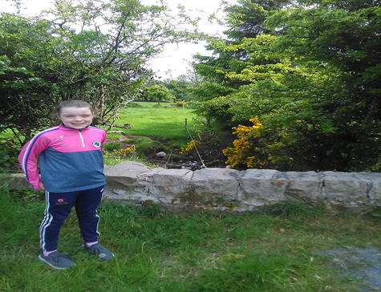. 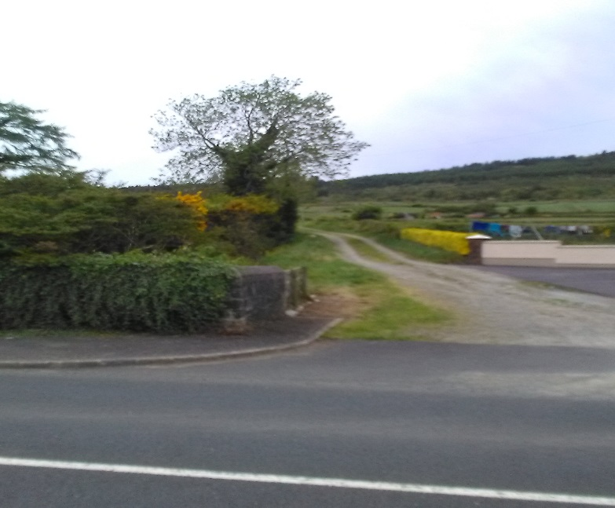

The road I live on runs through Dromintee and Aghadavoyle townlands.

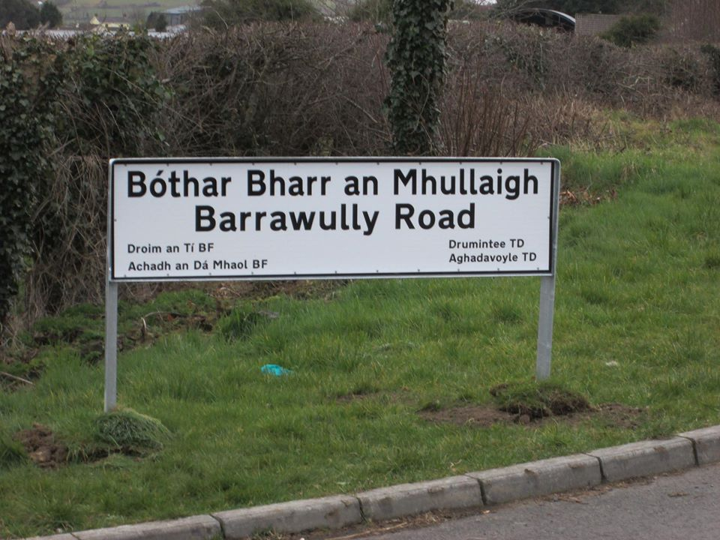

Here are some more pictures, if you can see where it says TD that tells you what townland that road is in.

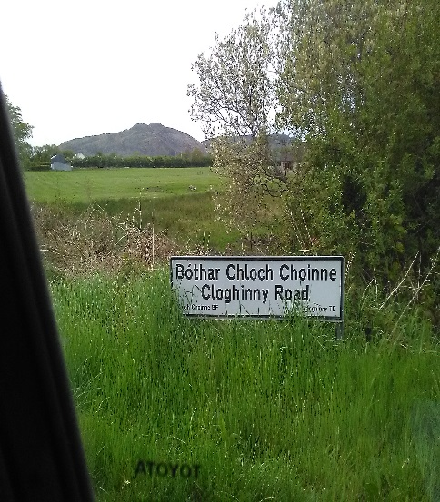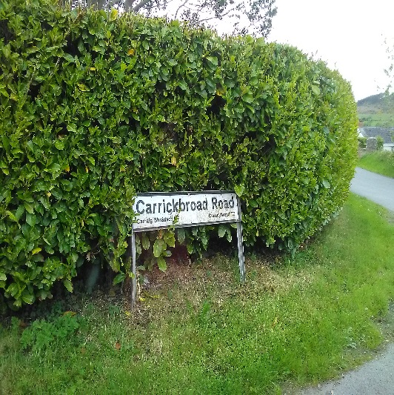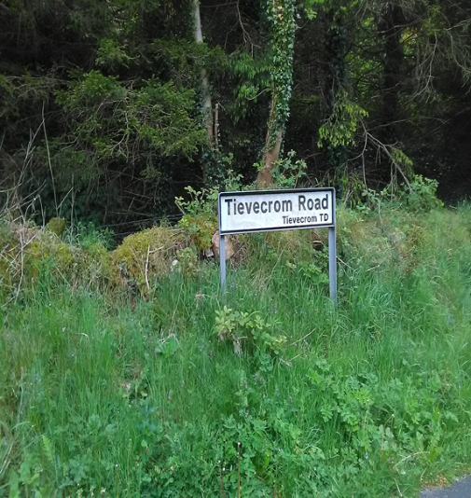

Key Viewing Points
The football club is in Aghadavoyle townland, the church is in Dromintee townland and Dromintee Primary School is in Dromintee townland. Moyry Castle is in Carrickbroad townland.
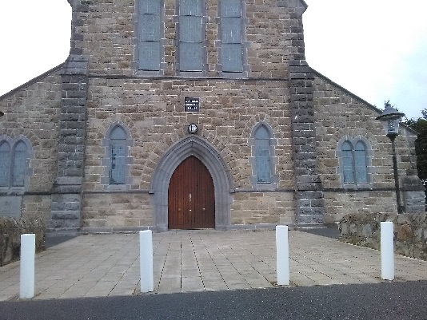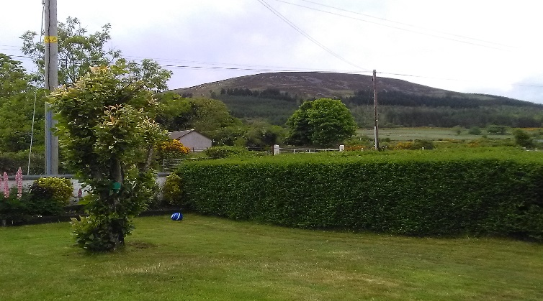

The Different Borders of My Townland
Aghadvoyle to the east
Annahaia to the north
Carrickbroad to the south
Cloghinny to the west
Foughill Otra to the east
Slieve Gullion to the north
Tievecrom to the south

Aghadavoyle / Achadh an Da Mhaoil:
- 367.06 hectares
- 1.42 square miles
- 907 acres
Nationwide, it is the 3336th largest townland that we know.
Within Co. Armagh it is the 33rd largest Townland.

Annahia/ Ath na hAithe:
- 264.16 hectares
- 1.02 square miles
- 652 acres
Within County Armagh it’s the 85th largest Townland and 6988th largest townland that we know.

Carrickbroad/Carraig Bhradach:
- 487.08 hectares
- 1.88 square miles
- 1203 acres
Within Co. Armagh it’s the 13th largest townland and 1622nd nationwide.

Cloghinny/ Cloch Eanaigh:
- 114.45 hectares
- .44 square miles
- 282 acres
It is the 25119th largest townland that we know.
In Co. Armagh it is 416th largest townland.

Foughill Otra/ Fochoill Uachtarach:
- 389.01 hectares
- 1.50 square miles
- 961 acres
Within Co. Armagh it’s the 30th largest townland and the 2898th nationwide.

Slieve Gullion/ Sliabh gCuilinn:
- 399.11 hectares
- 1.54 square miles
- 986 acres
Within County Armagh it’s the 26th largest townland and the 2719th nationwide.

Tievecrom/ An Taobh Chrom:
- 325.87 hectares
- 1.26 square miles
- 805 acres
Within County Armagh it’s the 49th largest townland and 4455th nationwide.

Fun Zone
Fun Facts: Moyry Castle was built in the 17th Century.
Dromintee Football club was founded in 1887.
Dromintee Church is over 150 years old
Slieve Gullion is the highest point in the county Armagh
Dromintee PS old school is now the home to the scouts

Word search: Words: Dromintee, Church, GAC, Moyry
D | R | O | M | I | N | T | E | E | Z
O | C | F | O | M | C | H | Y | F | C
V | S | I | Y | I | D | H | Y | Y | H
X | X | I | R | A | G | B | D | Q | U
V | L | H | Y | Z | T | I | Y | T | R
C | H | U | R | C | H | K | G | A | C

By Emma Toale

