Tievecrom- An Taobh Chrom by Niamh & Maeve Murphy
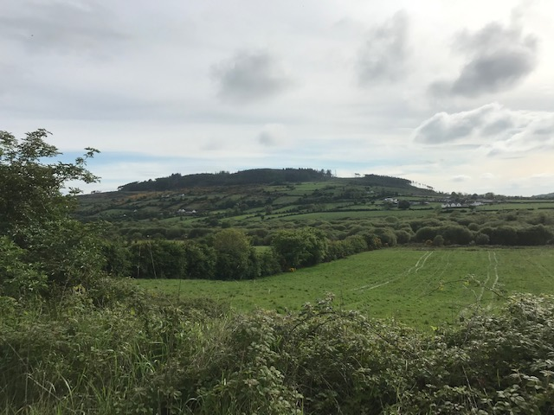
Tievecrom is located on the side of a small mountain at the south of Slieve Gullion and to the east of Forkhill. The townland of Tievecrom consists mainly of mountain land, from Glenn Du to Cloghinnea and bordered to the west by Carrickasticken and to the East across the Monribba Bog to Dromintee.
The ‘crom’ in the word Tievecrom means bent, crooked or inclined -these best describe the side of the moutain on which this townland is located.
Tievecrom means the stooped side or sloping hillside. In irish Tievecrom is spelt An Taobh Chrom. The height of Tievecrom mountain is 264m.
The first year Tievecrom was documented was in 1605. These are the different names Tievecrom had: 1605= Tewcrome 1609=Teecrum 1612 =Teocrum 1622= Tewcrom 1657= Tawcrome 1661= Towerowen 1672= TonreOune 1688= Teocram 1830c= Taobh Crom 1830c= Teevecrom 1830c= Tiefcrum 1834c= Tiffcrom or Tivecrum 1835c = Tifcrum 1994= Toabh Crom 2003= An Toabh Chrom 2003= Tievecrom.
In 1864 the farmers in Tievecrom didn’t own their own farms and they rented the farms from landlords. My great great great grand father James Tiernan rented 13 acres of farm land and he had to pay £11 and 5 shillings to Captain Henry Alexander from London who was the landlord.
The earliest date on record that our Maternal Family Tiernans were resident in the townland was 1858.
My distant cousin Rosie Tiernan lived alone with her two goats in a house with only two rooms. Rosie’s house had a large rock in the middle of it with a clay floor and whitewashed walls. Poor Rosie was fined £5 by Captain Alexander (the landlord) for taking brackens from Tievecrom mountain for her goats to sleep on, Rosie didn’t have 5 shillings never mind £5! 