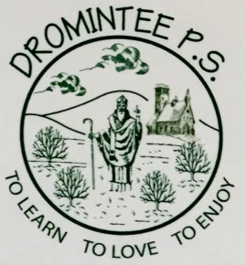 | Dromintee Primary School
 | 8 Ballynamadda Road,  Killeavy,  Newry, Co Down,  BT35 8TD | Telephone: (028) 3088 8383  Fax: (028) 3088 8470  www.drominteeps.com  Email: info@dromintee.killeavy.ni.sch.uk

May 2016 Servers :

Friday 6th and Sun. 8th May – Cara Toale, Katie O’Rourke, Mark McArdle, Conor McArdle (Group 7)
Friday 13th and Sun. 15th May – Sarah Graham, Oran Harris, Micheal McCreesh, Alannah Geoghegan (Group 1)
Friday 20th and Sun. 22nd May – Mark McArdle, Aoibh O’Neill, Conor McArdle, Mollie Morgan (Group 2)
Friday 27th and Sun. 29th May – Eoin Martin, Chloe Murphy, Ruben O’Rourke, Sarah Conlon (Group 3)

Friday Mass is at 9.30am and Sunday Mass is at 11 am.
Please be in the Church 15 mins before Mass begins.
If you cannot serve on your given dates please ask another server to serve for you.

