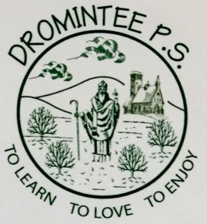 | Dromintee Primary School
 | 8 Ballynamadda Road,  Killeavy,  Newry, Co Down,  BT35 8TD | Telephone: (028) 3088 8383  Fax: (028) 3088 8470  www.drominteeps.com  Email: info@dromintee.killeavy.ni.sch.uk
Servers List

December 2019
Fri 6th & Sun 8th December – Sean Carragher, Caitlin Carnegie, Niamh Murphy, Kieran O’Neill (Gp3)
Fri 13th & Sun 15th December – Mary Ellen McKinney, Cara Harris, Ollie Rice, Grace McShane, Siofra McCreesh (Gp4)
Fri 20th, Sun 22nd & Christmas Eve – Sarah Murphy, Stephen Phelan, Emily McArdle, Jarlath O’Neill (Gp1)
Wed 25th December – Christmas day – Matthew Geoghegan, Maggie Boden, Ronan Martin, Eibhleann Hughes (Gp2)
Sunday 29th December – Sean Carragher, Caitlin Carnegie, Niamh Murphy, Kieran O’Neill (Gp3)

January 2020
Sunday 5th January – Mary Ellen McKinney, Cara Harris, Ollie Rice, Grace McShane, Siofra McCreesh (Gp4)
Fri 10th & Sun 12th January – Sarah Murphy, Stephen Phelan, Emily McArdle, Jarlath O’Neill (Gp1)
Fri 17th & Sun 19th January – Matthew Geoghegan, Maggie Boden, Ronan Martin, Eibhleann Hughes (Gp2)
Fri 24th & Sun 26th January – Sean Carragher, Caitlin Carnegie, Niamh Murphy, Kieran O’Neill (Gp3)
Fri 31st Jan & Sun 2nd Feb – Mary Ellen McKinney, Cara Harris, Ollie Rice, Grace McShane, Siofra McCreesh (Gp4)

Sunday Mass is at 11 am.
Please be in the Church 15 mins before Mass begins. If you cannot serve please ask someone else to serve for you.

