Dromintee Primary School Safeguarding Team
When I am I can talk to:
Mrs Fiona Fearon  (Designated Teacher for Child Protection) | Mrs Michelle Kelly  (Deputy Designated Teacher for Child Protection)
Mrs Wendy McKeown  (Principal)  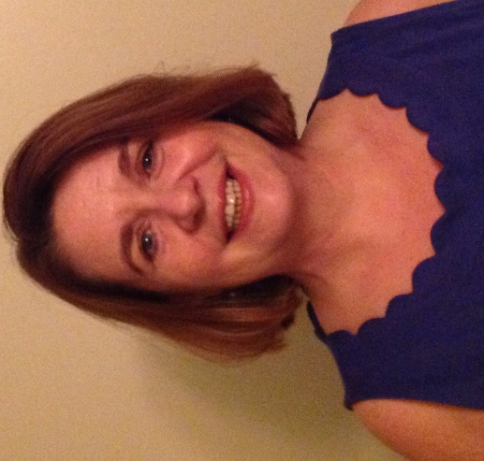 | Mrs Lisa McCrink  (Designated Governor for Child Protection)
or any safe adult in the school.

