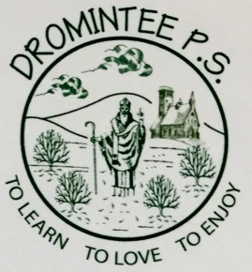 | Dromintee Primary School
 | 8 Ballynamadda Road,  Killeavy,  Newry, Co Down,  BT35 8TD | Telephone: (028) 3088 8383  Fax: (028) 3088 8470  www.drominteeps.com  Email: info@dromintee.killeavy.ni.sch.uk

October Servers

October 2019

Friday 4th & Sunday 6th October – Emily McArdle, Jarlath O’Neill, Ronan Martin, Eibhleann Hughes
Friday 11th & Sunday 13th October - Niamh Murphy, Kieran O’Neill, Ollie Rice, Cara Harris, Grace McShane
Friday 18th & Sunday 20thOctober - Emily McArdle, Jarlath O’Neill, Ronan Martin, Eibhleann Hughes
Friday 25th & Sunday 27th October - Niamh Murphy, Kieran O’Neill, Ollie Rice, Cara Harris, Grace McShane

Sunday Mass is at 11 am.
Please be in the Church 15 mins before Mass begins. If you cannot serve please ask someone else to serve for you.

