World Book Day 2019 Class Activities 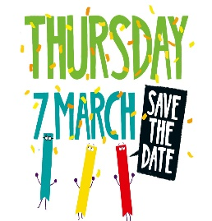

Primary 1 – P1 pupils will be celebrating World book Day by having a cosy day in school. Pupils are asked to bring in their slippers and favourite teddy. We will read some well-known favourite stories and celebrate with hot chocolate and biscuits.

Primary 2 – We are going to do a carousel of different things; each table will be named after a book.
These are the following table names:
- Fairytales
- Star Wars
- Gruffalo
- Roald Dahl
At each table there will be different things happening. Each child will get chance to go to each table.

Fairytale Table:
Design a house for the three little pigs using our junk box.
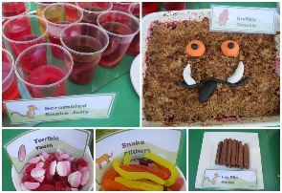
Star Wars Table:
Using lego to create a rocket ship for space and then writing about how they designed their ship.
Gruffalo Table:
Creating gruffalo treats i.e. using rice crispy buns
Roald Dahl
Creating a magic recipe for based on the book 'the witches' and 'creating a wish jar'.
We will make a treat like this for the afternoon whilst watching the narration of The Gruffalo. In addition, freeze frames from traditional fairytales.

Primary 3 - Are having a 'world book day' scavenger hunt in pairs.
- WHO AM I? can you guess the fairy-tale character? (linked to literacy topic)
- cooking activity, cooking rice crispy buns.
- reading a story while eating our buns.

Primary 4 – World Book Day cooking activity with whole class based around some of our favourite books and stories.

Primary 5 – Will be participating in Quiz Time
- Sharing a Story Poster
- Reading Stars
- Creating their own Bookmarks
- Can you make your own Fizz Potion? Inspired by 'The BFG' by Roald Dahl
- Colour Tokens competition

Primary 6 – Will be taking part in the "Share a story reading challenge".
Doing drama activities based on Michael Morpurgo - Private Peaceful
‘Where's Wally?’ worksheet.

Primary 7 - In P7 we will be writing and performing a screenplay of a section of our class novel, “Under the Hawthorn Tree.”

